 |  | 
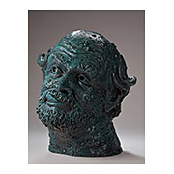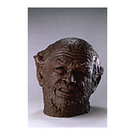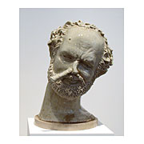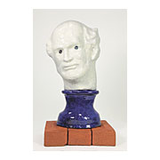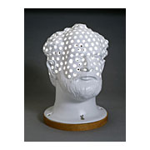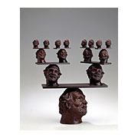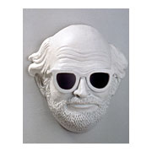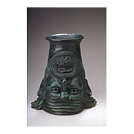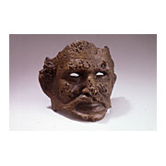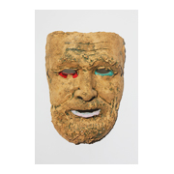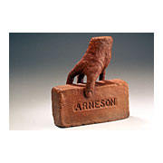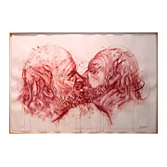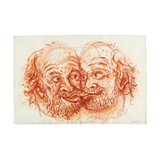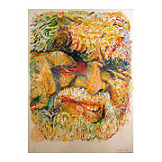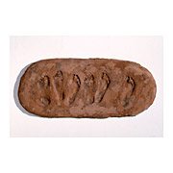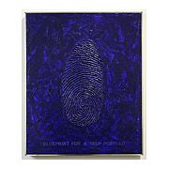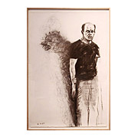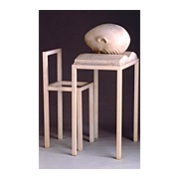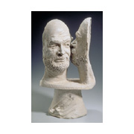 |  | Biography  1930 Born in Benicia, California  1954 BA, California College of Arts and Crafts, Oakland, California  1958 MFA, Mills College, Oakland, California  1962-1991 Faculty, University of California, Davis  1992 Died in Benicia, California  Selected Solo Exhibitions  2012 Self-Portraits in Bronze, Brian Gross Fine Art, San Francisco  2008 From the 60's, Brian Gross Fine Art, San Francisco  2004 Political Drawings, Brian Gross Fine Art, San Francisco  2004 Arneson and the Object, Palmer Museum of Art, The Pennsylvania State University, University Park, PA; Greenville County Museum of Art, Greenville, SC; George Adams Gallery, NY  2000 "This Head is Mine," The Contemporary Museum, Honolulu, HI  1999 Robert Arneson: Double Portraits, Brian Gross Fine Art, San Francisco, CA (catalogue)  1999 Robert Arneson: Bronze Self-Portraits and Drawings, DeCordova Museum and Sculpture Park, Lincoln, MA (catalogue)  1998 Robert Arneson: Guardians of the Secret II, George Adams Gallery, New York, NY  1997 Robert Arneson: Self-Reflections, San Francisco Museum of Modern Art, CA (catalogue)  1996 Robert Arneson: Drawing, George Adams Gallery, New York, NY (catalogue)  1995 Robert Arneson: The Late Bronzes, Frumkin/Adams Gallery, New York, NY  1993 Arneson and Politics: A Commemorative Exhibition, M.H. de Young Memorial Museum, CA (catalogue)  1993 Robert Arneson: The Last Works, John Berggruen Gallery, San Francisco, CA (catalogue)  1992 Robert Arneson: Guardians of the Secret II, Institute of Contemporary Art, University of Pennsylvania, Philadelphia, PA  1991 Robert Arneson: The Jackson Pollock Series, List Visual Arts Center, MIT, Cambridge, MA  1988 Robert Arneson: Art and Artists, Fuller Gross Gallery, San Francisco, CA  1987 Robert Arneson: Portrait Sculpture, Cleveland Museum of Art, OH (catalogue)  1986 Robert Arneson: A Retrospective, Des Moines Art Center, IA; Hirshhorn Museum and Sculpture Garden, Washington, DC; Portland Art Museum, OR; The Oakland Museum, CA (catalogue)  1979 Robert Arneson: Self-Portraits, Moore College of Art, Philadelphia, PA (catalogue)  1974 Robert Arneson, (retrospective exhibition), Museum of Contemporary Art, Chicago, IL; San Francisco Museum of Modern Art, CA (catalogue)  Selected Group Exhibitions  2007 Jackson, Contemporary Art Galleries, University of Connecticut, Storrs, Connecticut  2007 Dialogues: The Enigmatic Object, George Adams Gallery, New York, New York  2007 Inside/Outside, George Adams Gallery, New York, New York  2007 CCA at di Rosa Preserve: Art & Nature, Gatehouse Gallery, Napa, California  2006 2006 Collector's Show & Sale, Arkansas Art Center, Little Rock, Arkansas  2006 The Artful Jester, The Painting Center, New York, New York; Brattleboro Museum and Art Center, Vermont  2005-2006 Art of Engagement: Paintings, Drawings, Prints, and Sculpture, Jack Rutberg Fine Arts, Los Angeles, California  2005 Fired at Davis: Figurative Ceramic Sculpture from the Paula and Ross Turk Collection, Cantor Arts Center, Stanford, California  2005 Body Language, George Adams Gallery, New York, New York  2005 Paint on Metal: Modern and Contemporary Explorations and Discoveries, Tuscon Museum of Art, Arizona  2004 "Bush-Whack!", George Adams Gallery, New York, NY  2001 Poetics of Clay: An International Perspective, Philadelphia Art Alliance, Philladelphia, PA  1999 The Art of Craft: Contemporary Works from the Saxe Collection, M.H. de Young Memorial Museum, San Francisco, CA  1998 Leonardo Lives: The Codex Leicester and Leonardo Da Vinci’s Legacy of Art and Science, Seattle Art Museum, WA  1995 Facing Eden: 100 Years of Landscape Art in the Bay Area, M.H. de Young Memorial Museum, San Francisco, CA  1995 Inside Out: Psychological Self-Portraiture, Aldrich Museum of Contemporary Art, Ridgefield, CT  1994 Black Male: Representations of Masculinity, Whitney Museum of American Art, New York, NY  1994 Elvis + Marilyn: 2 X Immortal, Institute of Contemporary Art, Boston, MA; travelled  1992 Arneson, De Forest, Hudson, Wiley, San Jose Museum of Art, CA  1986 California Figurative Sculpture, Palm Springs Desert Museum, CA  1984 The Human Condition: Biennial III, San Francisco Museum of Modern Art, CA  1981 Ceramic Sculpture: Six Artists, Whitney Museum of American Art, NY  1980 Sculpture in California 1975-1980, San Diego Museum of Art, CA  1979 West Coast Ceramics, Stedelijk Museum, Amsterdam  1979 A Century of Ceramics in the United States, 1878-1978, Everson Museum of Art, Syracuse, NY; travelled  1977 Sculpture: American Directions 1945-75, National Collection of Fine Arts, Smithsonian Institution, Washington, DC  1970 Annual Exhibition: Contemporary American Sculpture, Whitney Museum of American Art, New York  1969 The Spirit of Comics, Institute of Contemporary Art, University of Pennsylvania, Philadelphia  1968 Dada, Surrealism, & Their Heritage, Museum of Modern Art, New York, NY  1967 Funk Art, University Art Museum, University of California, Berkeley, CA  1967 Arts of San Francisco, San Francisco Museum of Modern Art, CA  Selected Public Collections  Aichi Prefectural Ceramic Museum, Japan  The Art Institute of Chicago, Illinois  Australian National Gallery, Canberra  Berkeley Art Museum, University of California, Berkeley  The Cleveland Museum of Art, Ohio  Denver Art Museum, Colorado  Hirshhorn Museum and Sculpture Garden, Washington, DC  The Jewish Museum, New York, New York  Los Angeles County Museum of Art, California  The Metropolitan Museum of Art, New York, New York  Museum of Contemporary Art, Chicago, Illinois  Museum of Fine Arts, Boston, Massachusetts  Museum of Modern Art, Shiga, Japan  The Museum of Modern Art, New York, New York  National Museum of American Art, Washington, DC  National Museum of Modern Art, Kyoto, Japan  The Nelson-Atkins Museum of Art, Kansas City, Missouri  The Oakland Museum, California  Philadelphia Museum of Art, Pennsylvania  Phoenix Art Museum, Arizona  San Francisco Museum of Modern Art, California  Santa Barbara Museum of Art, California  Seattle Art Museum, Washington  Shigaraki Ceramic Cultural Park, Japan  The St. Louis Art Museum, Missouri  Stedelijk Museum, Amsterdam, The Netherlands  Wadsworth Atheneum, Hartford, Connecticut  Whitney Museum of American Art, New York, New York

